Health and Impact Assessment (HIA) for Planning - Screening Tool

Application Reference:

QUESTION |  | NO | YES | ACTION
1) | Is the site allocated for development in the current Development Plan or the emerging Local Plan?  (See Local Plan Policies Map) |  |  | Proceed to Qs 2 and 3.
2) | Does the proposed development site include  - more than 50 houses  - an area greater than 10,000 square metres (2.47 acres/ 1 hectare) or,  - a mixture of the two? |  |  | If Yes to any a Comprehensive HIA is required.  If No, proceed to Q3
3) | Is the proposed development in or neighbouring an area of deprivation, or likely to have a significant impact upon an area of deprivation? (i.e., in an area ranked by the Index of Multiple Deprivation amongst the 10% or 20% most deprived in Doncaster. (See map overleaf.) |  |  | If Yes, a Comprehensive HIA is required.
4) | Does the scheme involve a hot food takeaway or gambling/gaming establishment? |  |  | If Yes please inform Public Health.
5) | Is the scheme for Houses in Multiple Occupation (HMOs)? |  |  | If Yes, please complete the HMO specific HIA.
6) | Are there any exceptional circumstances where a HIA may be requested by Public Health? |  |  | If Yes or unsure Inform Public Health.

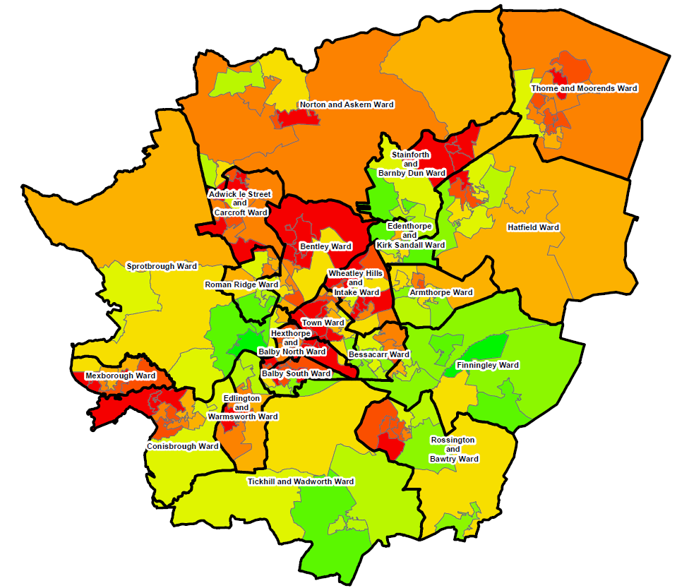
Overall deprivation 2019
Index of Multiple Deprivation (IMD) Decile (where 1 is most deprived 10% of LSOAs

